Human Resource Module

Main Database
Department
Designation
Employee
Employee Details

Salary Details

Main Transactions
Modifying Department

Modifying Designation

Modifying Grade

Letter Transaction

Table of Contents

Requirements Analysis
Systems Characteristics
Integration with Other Modules
User Pre-Requisites
Getting Started
Setups
- Department File ......................................................................................................
- Designation File …………………………………………………………………………………………………..
- Grade File …………………………………………………………………………………………………………..
- Payment Mode File ………………………………………………………………………………………………
- HR Master File ………………………………………………………………………………………..…………..
- Salary Master File ……………………………………………………………………………………………….
- Snaps File …………………………………………………………………………………………………………..

Transactions
- Modifying Department …………………………………………………………………………………………
- Modifying Designation …………………………………………………………………………………………
- Modifying Grade …………………………………………………………………………………………………
- Letter Transaction ………………………………………………………………………………………………
- Department Goal ………………………………………………………………………………………………..
- Individual Goal …………………………………………………………………………………………………..
Reports
- Department Listing ……………………………………………………………………………………………
- Designation Listing …………………………………………………………………………………………….
- Grade Listing …………………………………………………………………………………………………….
- Payment Mode Listing ………………………………………………………………………………………..
- HR Master Listing ……………………………………………………………………………………………….
- Salary Master Listing …………………………………………………………………………….. ………….
- Setup Profile Listing ……………………………………………………………………………………………
- Modifying Department Listing ……………………………………………………………………………..
- Modifying Designation Listing ……………………………………………………………………………..
- Modifying Grade Listing ………………………………………………………………………………………
- Letter Transaction Listing ……………………………………………………………………………………
- Department Goal Listing………………………………………………………………………………………
- Individual Goal Listing …………………………………………………………………………………………
Utility Tools
(None)

Security
- User Access Right ………………………………………………………………………………………………...

Requirements Analysis
Systems Characteristics
Integration with Other Modules

HR Module is linked with the following FCL modules:
GF

PF HR PY

MSM
Dependency Diagram
- Payroll -PY
- Provident Fund Trust -PF
- Gratuity Fund -GF
- Medical Surveillance -MSM

All the above-listed modules use HR Employee master file. But they maintain their own database for their respective kind of information about FCL employees with the reference of ‘employee code’; hence, the HR database remains unaffected (exception: Full & Final Settlement Transaction of Payroll; see the same section in Payroll Manual for details).

Relationship

- Specifying an employee’s ‘Date Left’ in the FCL HR Module has the following impacts:
1) the employee becomes a right candidate for Full & Final Settlement by Payroll module
2) the employee is no longer eligible for other attendance and payroll transactions; obviously, because he/she has left the FCL job
3) the employee is no longer eligible for Medical Surveillance transactions
[moretosay]

User Pre-Requisites

Getting Started

Setup
_______________________________________________________________________________

The FCL Human Resource Module setup files are data entry screens for maintaining the following information about the FCL employees:

- Department
- Designation
- Grade
- Payment Mode
- HR Master
- Salary Master
- Snaps

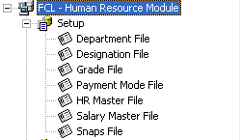 | 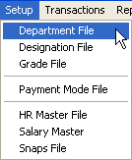

In the subsequent pages, each Setup entry is described briefly with the help of screen-shots.

Department File
_______________________________________________________________________________

Description
In this form we define different FCL departments with respect to labor rather than products, with the following mandatory and optional information:
Mandatory information:

- Department Code
- Department Name
- Nature – whether it is a Production or Non-Production department

Optional information:

- Reporting person
- Controlling Manager
- Customer’s Sharing %
- Strength of Department

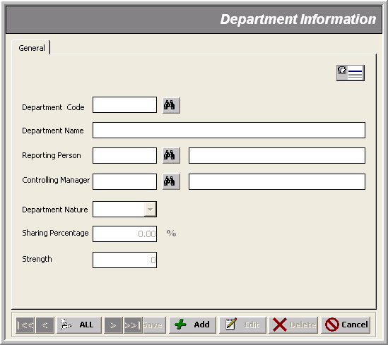
* Department Name (@³⁰)

* Department Code (@²)
Reporting Employee

Controlling Employee

* Nature (Production/Non-Production)
Customer’s Share
No. Of Employee

Designation File
_______________________________________________________________________________

Description
A simple Code-Name data entry form where we define designations for the FCL employees of all departments.

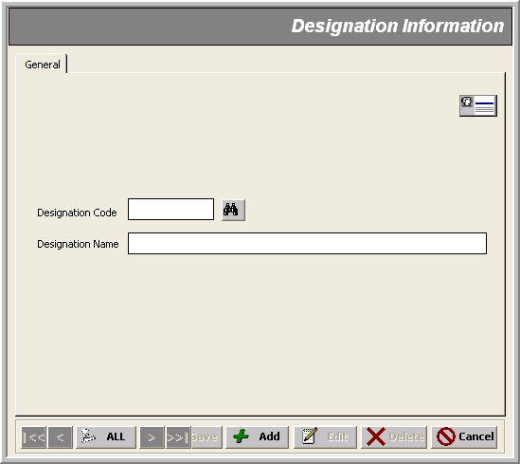
* Designation (@³⁰)

* Designation Code (@@@@)

Grade File _______________________________________________________________________________

Description
Here we define different grades in which all FCL employees fall in with respect to Salary terms such as basic salary, allowances and deductions.

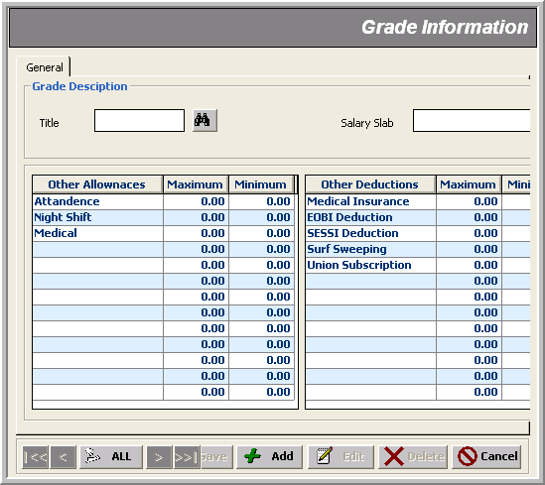
* Title (@@@)
* Salary Slab (@^{n})
Allowances Detail
Deductions Detail

Payment Mode File _______________________________________________________________________________

Description
A simple Code-Name data entry form for keeping record of different modes of payment to be applicable while making payments to the FCL labor.

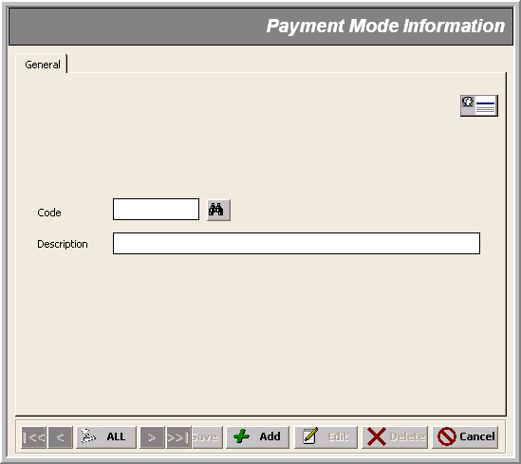
* Payment Mode
* Code (@@)

HR Master File
_______________________________________________________________________________

Description
Here we specify every single information about FCL labor to be employed in FCL’s Payroll and Financial modules.

Mandatory information includes:

- Name
- Father’s Name
- Department
- Designation
- Grade
- Type
- Category
- Shift
- Joining date
- Confirmation date
- EOBI Contribution
- SESSI Contribution
- Birth Date

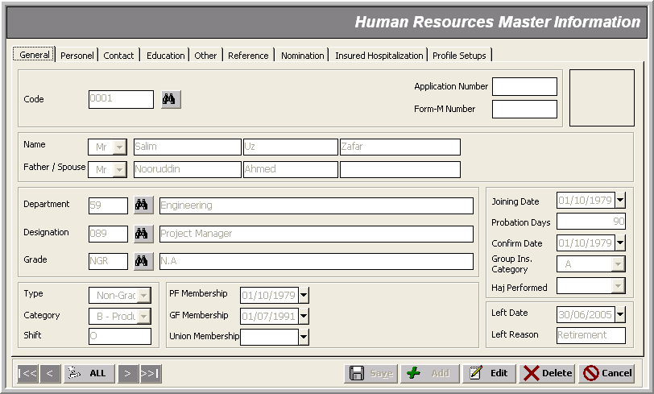
* Employee’s Job Information

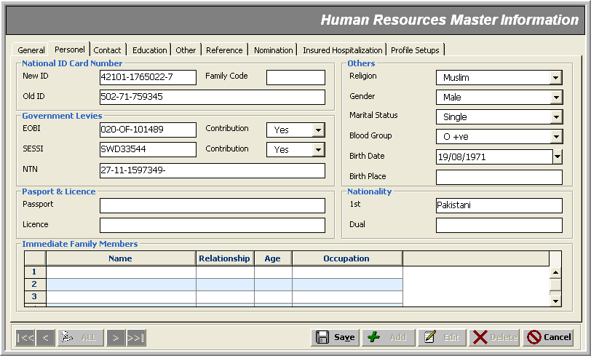
* Employee’s Personal Information

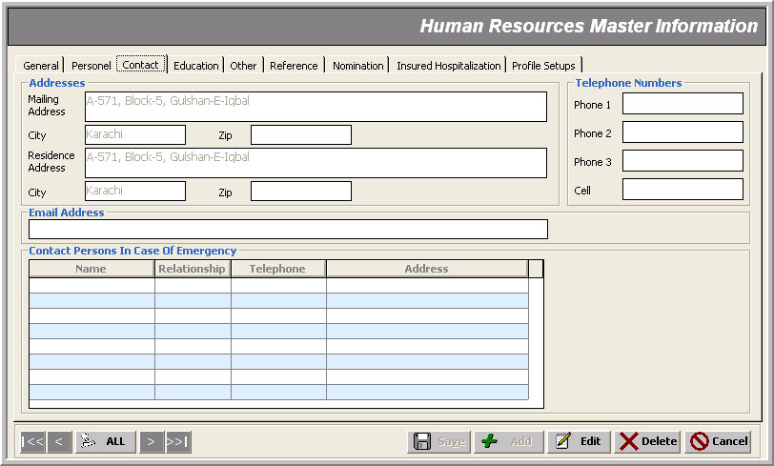
* Employee’s Contact Information

Employee’s Educational Information
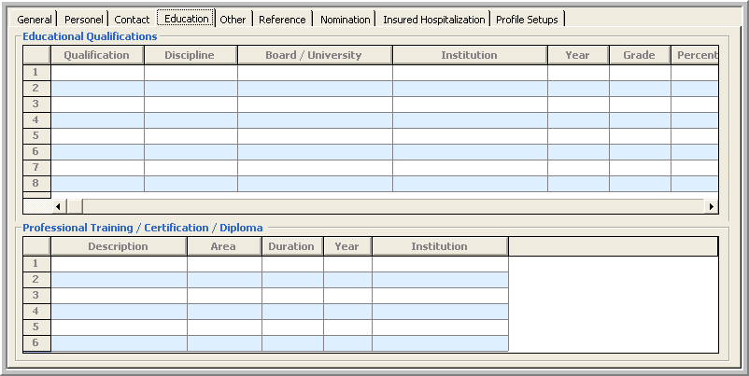

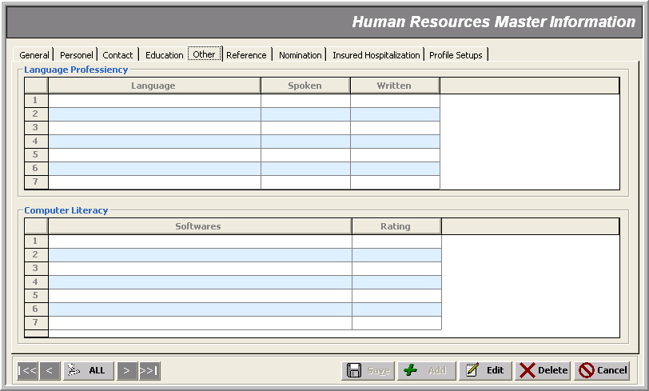
Employee’s Other Skills Information
Employee’s Reference Information
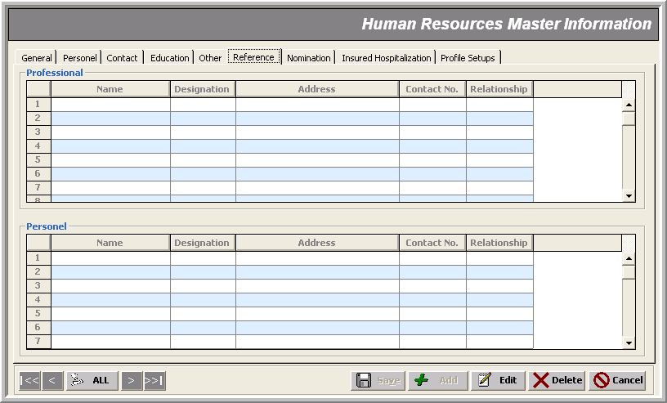
Employee’s Shares Information
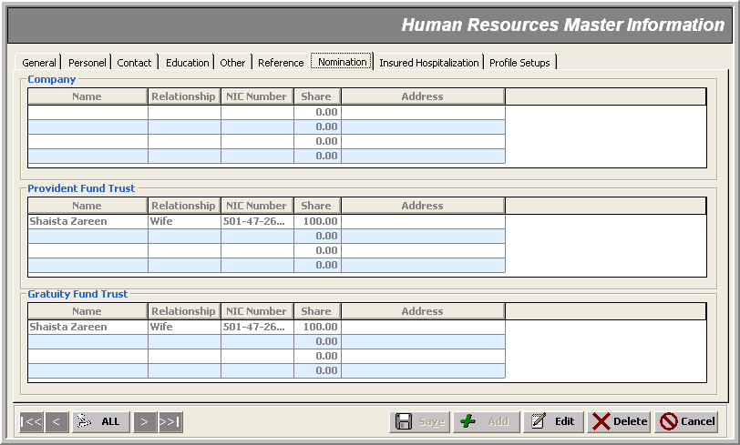
Employee’s Insurance Information
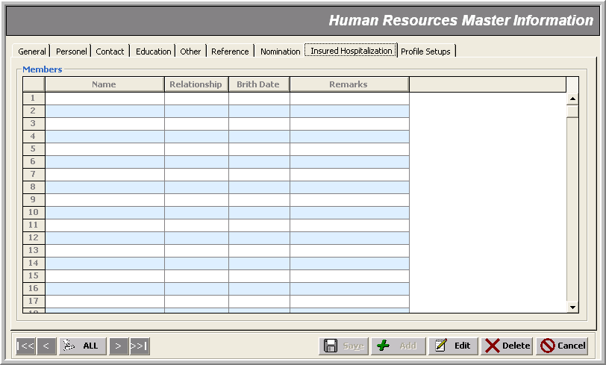
FCL ERP Modules using Employee’s Reference Information
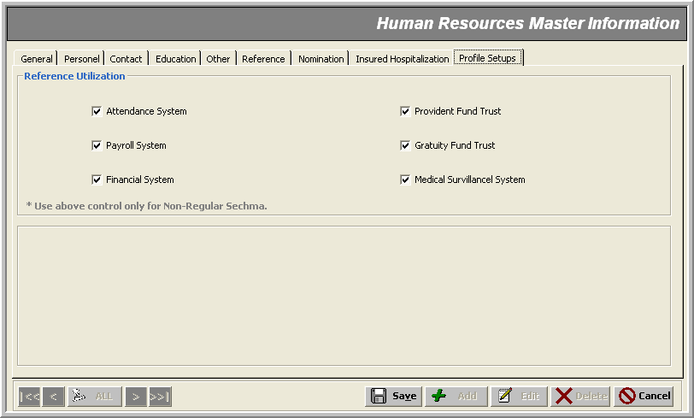

Salary Master File
_______________________________________________________________________________

Description
This from is used to keep information about an employee’s remuneration details. Some of the information specified here comes from the employee’s HR Master File.

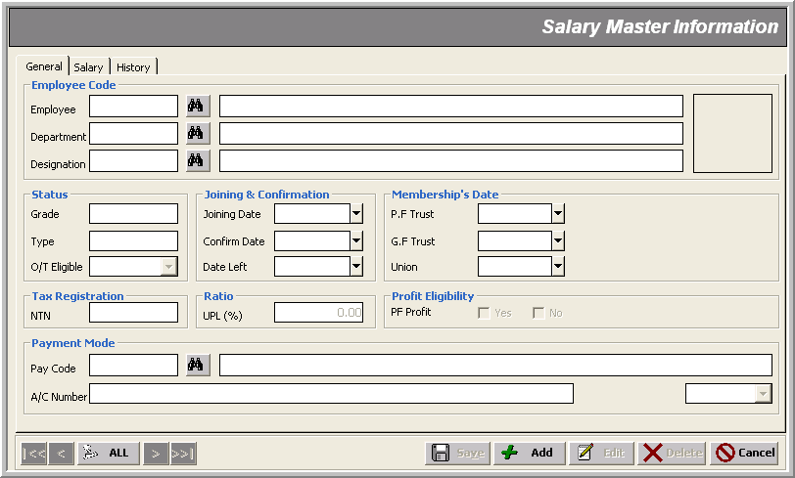
Employee’s Salary Terms
Employee’s Salary Breakups

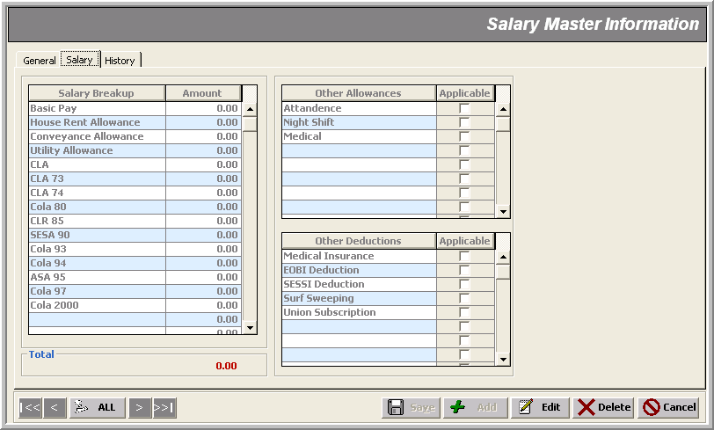
Employee’s Allowances

Employee’s Salary Deductions

Employee’s Salary Increment History

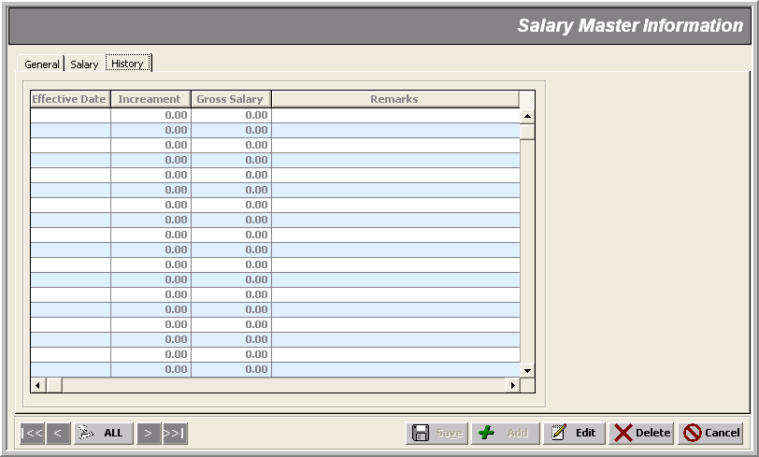

Snaps File
_______________________________________________________________________________

Description
A simple Photo Gallery of an FCL employee’s snaps.

Note that:
- All images are provided and saved away locally (i.e. in the server’s local drive) . There’s no database involvement.
- Images are inserted by right clicking on the white canvas area provided
- Multiple images are possible to save away
- ‘Save/Add/Edit/Delete’ Control-buttons are there only for the actual record not the snaps being inserted/deleted; for these actions you use the menu popped up on the right-click
Employee Snaps
* Department

* Designation
* Employee Code

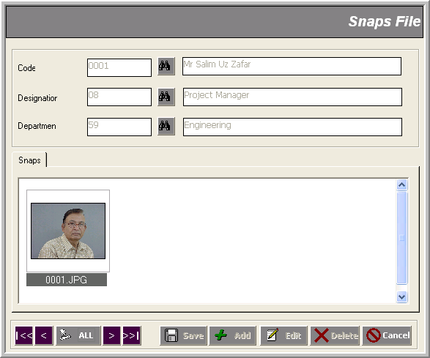

Transactions
_______________________________________________________________________________

In all the transaction entries of the FCL Human Resource Module, the administrator does the following jobs:

- modifying an employee’s job status
- issuing him letters

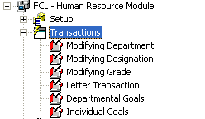 | 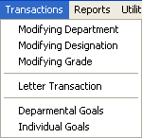

Modifying Department _______________________________________________________________________________
Use case: Moving an Employee to a New Department

Description
Good or bad news! The administrator has the right to tag an employee belonging to another department. This might require him to change/modify some other job descriptions of this employee as well; such as Designation, Grade and Salary terms.

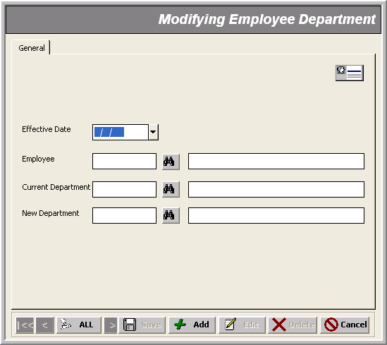
* Employee Code
* Effective Date
* Current Department
* New Department

Modifying Designation _______________________________________________________________________________
Use case: Assigning a New Designation to Employees

Description
By this transaction, the administrator can change an employee’s designation. Again, this might require him to change/modify some other job descriptions of this employee as well; such as Grade and Salary terms. An Effective Date keeps track of what day the employee is going to enjoy/suffer that position from.

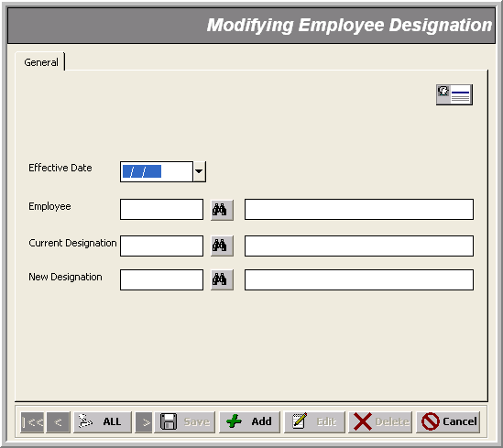
* Employee Code
* Effective Date
* Current Designation
* New Designation
Modifying Grade _______________________________________________________________________________
Use Case: Assigning a New Grade to Employees

Description
Here the administrator can change an employee’s grade. Again, this might require him to change/modify some other job descriptions of this employee as well; such as Designation and Salary terms. An Effective Date keeps track of what day the employee is going to enjoy/suffer that position from.

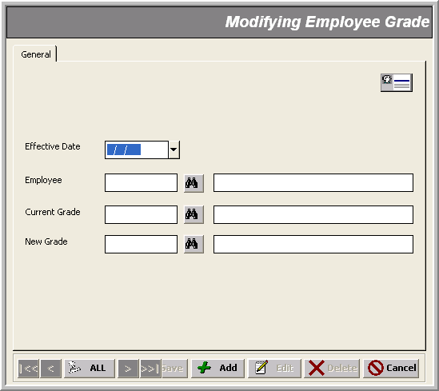
* Employee Code
* Effective Date
* Current Grade
* New Grade
Letter Transaction _______________________________________________________________________________
Use Case: Issuing Letters to Employees

Description
This is an automated letter generation tool. All the administrator has to do to issue an employee a letter is just specify some basic information and here you go! You find a well-formatted company letter down there in the reports arena – Letter Transaction Listing.

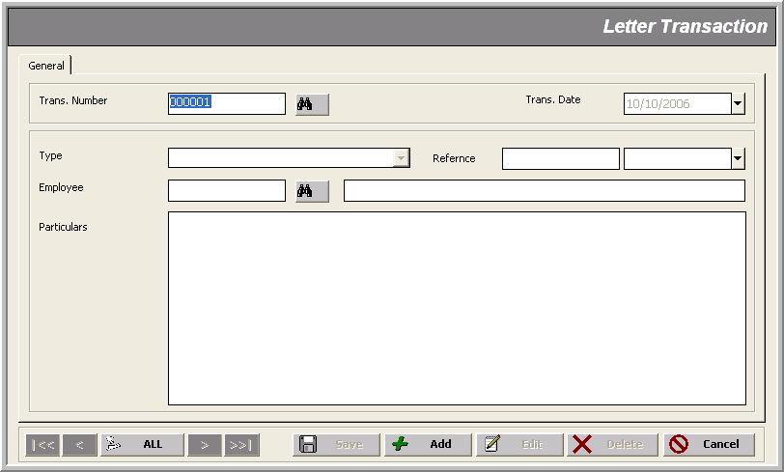
Date of Ref #
Reference
* Letter Type
* Transaction Number
* Transaction Date
* Letter Type
Detail - to be merged in the letter body
Reports
_______________________________________________________________________________

The FCL Human Resource Module reports can be divided in two categories:

- Setup Reports
- Transaction Reports

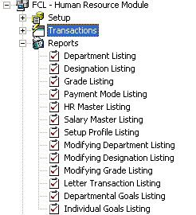 | 